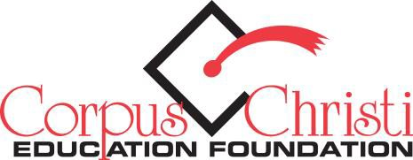

Board Members
2016-2017

Gina Prince
Chairman

Veronica Adams
Secretary

Pedro Azevedo
Finance & Governance Chair

Cecil Johnson
Development & Mktg Chair

Amy McCoy
Programs Chair

Dee Labay
Exec. At Large

Dr. Roland Hernandez
Superintendent of Schools

Pedro Azevedo
Janie Bell – Trustee Rep.
Kristen Bily
Christina Cisneros-Guzman
O.B. Garcia
Melanie Gavlik
Paige Kimball
Sam Longoria
Eric Newman
Tiffany Ramon
Collette Rye
Kelly Trevino
Kim Wilmoth

Peter Weil, Ex-Officio
Mary Williams, Ex-Officio

INDIVIDUAL TICKET ORDER FORM
2016 State of the District

*SPONSORSHIPS also available – visit www.ccef-ccisd.org and click “State of the District,” or call (361) 695-7412 for more information.

To order individual tickets, please provide all information requested below.

Contact Name: Company: Address:

Phone: E-mail: Website:

Individual Ticket Request:

I would like to request _ (additional) tickets at $50 each, to be mailed to the address above.

Enclosed is my check for $ payable to the Corpus Christi Education Foundation.

Please mail this completed form, and any payments (form can also scanned / emailed to Eloisa.Dowiat@ccisd.us):
Corpus Christi Education Foundation
P.O. Box 2822 • Corpus Christi, TX 78403

P.O. Box 2822 Corpus Christi, TX 78403 361-695-7412 www.ccef-ccisd.org information@ccef-ccisd.org The Corpus Christi Education Foundation provides funds and supports (CCISD) projects and programs that promote a culture of college readiness for all, recognize student achievement and teaching excellence and promoting innovative programming.

